**COVID -19 ANALAYSIS**

**PHASE 5**

|  |  |
| --- | --- |
| **Date** | **31-10-2023** |
| **Team ID** | **720** |
| **Project Name** | **Covid-19 Cases Analysis** |

|  |  |  |
| --- | --- | --- |
| **SNO** | **TABLE OF CENTENTS** | **PAGE NO** |
| 1 | INTRODUCTION | 2 |
| 2 | PROBLEM STATEMENT | 2 |
| 3 | PROBLEM IDENTIFIED | 3 |
| 4 | LITERATURE SURVEY | 3 |
| 5 | DESIGN THINKING | 5 |
| 6 | DEVELOPMENT PHASE | 12 |
| 7 | ANALYSIS OBJECTIVE | 16 |
| 8 | DATA COLLECTION | 16 |
| 9 | DATA VISUALISATION | 18 |
| 10 | CONCLUSION | 36 |

1. **INTRODUCTION**

The year 2021 marked a pivotal period in the global response to the COVID-19 pandemic. During the months of March, April, and May, the world continued its relentless battle against the virus, characterized by a complex interplay of rising cases, vaccination campaigns, and evolving public health measures. The data from this critical period holds the key to understanding the dynamics of the pandemic and shaping effective strategies for containment and mitigation.

In response to the pressing need highlighted by our problem statement, this study embarks on a comprehensive analysis of COVID-19 cases, deaths, and associated trends within the specified timeframe. Our aim is to provide a deeper insight into the impact of the virus during these months, examining variations across countries and regions, identifying potential hotspots, and assessing the effectiveness of public health responses.

As we navigate the intricate landscape of COVID-19 data for March, April, and May 2021, our focus extends beyond mere statistics. It encompasses the stories of resilience, sacrifice, and scientific innovation that unfolded during this period. We seek to illuminate the challenges and milestones, capturing the experiences of different nations and regions as they grappled with the pandemic's waves.

Through this analysis, we hope to empower decision-makers, healthcare professionals, and the public with valuable insights that can guide evidence-based responses, resource allocation, and the ongoing global effort to combat the pandemic. The data from these three crucial months is a treasure trove of information, and by exploring it in-depth, we aim to contribute to the collective knowledge that shapes our fight against COVID-19.

1. **PROBLEM STATEMENT:**

The project involves analysing COVID-19 cases and deaths data using IBM Cognos. The objective is to compare and contrast the mean values and standard deviations of cases and associated deaths per day and by country in the EU/EEA. This project encompasses defining analysis objectives, collecting COVID-19 data, designing relevant visualizations in IBM Cognos, and deriving insights from the data.

1. **PROBLEM IDENTIFIED:**

The global COVID-19 pandemic has created an urgent need for comprehensive and data-driven analysis of cases to inform public health policies and responses. As the virus's impact evolves, accurate and timely analysis of infection rates, transmission patterns, and vaccination effectiveness is paramount. However, the vast and dynamic nature of COVID-19 data, coupled with the need to integrate diverse sources of information, presents a complex challenge. Developing an accessible, robust, and up-to-date system for COVID-19 cases analysis is crucial to facilitate evidence-based decision-making and resource allocation.

**4. LITERATURE SURVEY**

* **1.“Clinical Microbiology and infection”, Anosmia in covid –19 patients,** **Burghart Sniffin[May-2020]**

Burghart Sniffin' Sticks®, a popular screening tool for smelling disorders, was utilized in a study to measure the severity of SARS-CoV-2-related smelling disorder in COVID-19 patients. According to the study, anosmia was diagnosed in 18 out of 45 patients (40%) with COVID-19 patients smelling four fewer sticks on average than uninfected controls. When it came to identifying anosmia, the Sniffin' Stick test was more accurate than self-reporting or obtaining a medical history. Patients with and without anosmia or hyposmia had comparable clinical pictures, test results, and outcomes at day 15. A quantitative and objective test revealed that 40% of the patients were hyposmia and nearly half were osmic. But only 49% of patients said they can smell.

* **2. “Covid-19 impact on students”,** **Andria Pragholapati[May-2020]**

Globally, the COVID-19 epidemic has had a major effect on businesses, tourism, health, and students. As the virus spreads among people, social and physical barriers are imposed, impacting not only educational institutions but also the commercial, tourist, and health sectors. The Ministry of Education and Culture in Indonesia has released a circular directing colleges to offer remote learning opportunities and recommending that student's study from home. Millions of pupils have been impacted by this, particularly those from marginalized and vulnerable areas. Healthy individuals, persons with monitoring (ODP), people without symptoms (OTG), patients with supervision (PDP), Covid-19 patients, and vulnerable groups are all subject to the policies of the Indonesian Ministry of Health. UNESCO assists nations in their attempts to lessen the immediate effects of closing schools and enable universal access to remote education.

* **3.“Covid-19 impacts on society”,** **Jaspreet Singh, Jagandeep Singh,[March-2020]**

Since its start in March 2020, the COVID-19 pandemic has had a significant negative influence on social interactions and relationships, which has resulted in stress, anxiety, sadness, mental disorders, and health risks. Over 420 million children and youth have been impacted by the virus, which has forced the closure of schools, colleges, universities, and other institutions. The virus can spread through inhalation or contact with sick individuals. People are being compelled to work from home and avoid social gatherings due to social distancing measures, which is resulting in a new phase of social suffering. Sociologist Eric Kleinberg of New York University cautions that social suffering associated with social separation and isolation will occur to an extent that is not yet widely discussed. Stressful states of anxiety, loneliness, anxiety drives, despair, and so on can result from the lack of deeply meaningful connections.

* **4.“A Mathematical model for covid-19 transmission dynamics with a case study of India”,** **Piu Samui, Jayanta Mondal, Subhas Khajanchi[August-2020]**

As of July 15, 2020, there were 968,117 confirmed cases, 612,782 recovered cases, and 24,915 deaths in India due to the ongoing COVID-19 pandemic, which has caused a serious global crisis. Predictive mathematical models can be used to manage and control coronavirus disease in the absence of effective treatments or medications and in the absence of an established epidemiological life cycle. This study uses epidemic data up to April 30, 2020, to propose a mathematical model to predict and control the COVID-19 pandemic's transmission dynamics in India. To examine model simulations and predictions, the model computes the fundamental reproduction number, or R0. To ascertain the relative significance of model parameters to the spread of disease, sensitivity analysis is performed. According to the model, COVID-19 peak in India is expected to be higher.

* **5.“Covid-19 vaccines and current opinion in immunology”,** **Duduzile Ndwandwe and Charles S Wiysonge[ July-2021]**

COVID-19 is a pandemic of unprecedented proportions, with nearly 200 million confirmed cases and four million deaths worldwide. Efforts have been made to find safe and effective vaccines, with 184 candidates in pre-clinical development, 105 in clinical development, and 18 approved for emergency use. These vaccines include whole virus live attenuated or inactivated, protein-based, viral vector, and nucleic acid vaccines. By mid-2021, three billion doses of COVID-19 vaccine have been administered worldwide, primarily in high-income countries. COVID-19 vaccination provides hope for an end to the pandemic, if equal access and optimal uptake are provided in all countries. Vaccines are biological preparations that provide active acquired immunity to a particular infectious disease by stimulating an immune response to an antigen. The pandemic has accelerated vaccine development, with 184 candidate vaccines in preclinical development and 104 in clinical stage.

1. **DESIGN THINKING**
   1. **Design Thinking Approach:**

**Empathize:**

To address the multifaceted challenges of COVID-19 analysis within IBM Cognos, it is imperative to empathize with the diverse stakeholders affected by the pandemic.

**Human Impact:** Remember that every data point represents a person, family, or community affected by the virus. Approach the data with empathy for those who have suffered.

**Health Disparities:** Acknowledge that certain groups may be disproportionately affected. Analyze data to understand and address health disparities and inequalities.

**Lives Lost:** Each death recorded in the dataset represents a loss. Empathize with the families and friends of those who have passed away.

**Recovery and Resilience:** Celebrate the stories of recovery and resilience. Focus on the number of people who have overcome the virus.

**Mental Health:** Consider the mental health impact of the pandemic. Analyze data related to mental health issues and seek ways to support affected individuals.

**Healthcare Workers**: Recognize the sacrifices and challenges faced by healthcare workers. Analyze data to identify areas where additional support is needed.

**Economic Impact:** Understand the economic consequences of the pandemic. Analyze data related to job losses, business closures, and economic recovery efforts.

**Vaccination Efforts:** Highlight the significance of vaccination campaigns in data analysis. Emphasize the positive impact of vaccination on reducing cases and deaths.

**Long COVID:** Analyze data on "long COVID" to empathize with those experiencing persistent symptoms after recovery.

**Community Response:** Recognize the strength of communities and their response to the pandemic. Analyze data related to community support and resilience.

**Education Disruption:** Consider the disruption in education and its impact on students, teachers, and families. Analyze data related to educational challenges.

**Isolation and Loneliness:** Empathize with those who have experienced isolation and loneliness. Analyze data on social connectedness and support systems.

**Global Solidarity**: Remember that COVID-19 is a global issue. Collaborate with international organizations and researchers for a holistic analysis.

**Public Health Measures:** Analyze the effectiveness of public health measures and consider the challenges faced by communities in adhering to them.

**Scientific Progress:** Celebrate the scientific progress made in understanding the virus and developing treatments and vaccines.

* 1. **Actions:**

Conduct interviews with healthcare professionals to understand their data requirements and decision-making processes.

Engage in discussions with policymakers to identify their priorities for data-driven insights.

Listen to the concerns and questions of the general public through surveys and social media sentiment analysis.

* 1. **Define:**

Based on our empathetic understanding, we will define clear objectives and success criteria for our COVID-19 analysis project within IBM Cognos.

* 1. **Objectives:**

Develop data cleansing processes in IBM Cognos that ensure data accuracy and completeness.

Create IBM Cognos dashboards and reports that provide real-time COVID-19 insights.

Produce data-driven narratives and visualizations within IBM Cognos that inform policy decisions.

* 1. **Ideate:**

Brainstorm innovative solutions within the IBM Cognos framework to address the defined objectives. The objective of this data analysis is to calculate the standard deviation (STD) and mean of two key variables, namely, "Death Cases" and "Total Cases," in the COVID-19 dataset. These statistical measures are essential for understanding the spread and impact of the virus, as well as for making informed decisions and policy recommendations. By obtaining the STD and mean values for these variables, we aim to provide insights into the distribution and central tendencies of COVID-19 cases and deaths, facilitating data-driven decision-making and further analysis.

With this well-defined problem, you can proceed to collect and analyze the data to calculate the standard deviation and mean of death cases and total cases in the COVID-19 dataset.

* 1. **Actions:**

Explore IBM Cognos' data integration capabilities to ensure seamless data access and cleansing.

Investigate advanced reporting and visualization techniques within IBM Cognos for conveying COVID-19 trends effectively.

Consider user-friendly dashboard design principles and storytelling techniques for data communication.

* 1. **Prototype:**

A prototype for working in IBM Cognos for visualization involves creating a sample dashboard or report to demonstrate the capabilities of the Cognos platform. Here are 10 key components to include in this prototype:

Data Source Connection: Establish a connection to a data source (e.g., a database or spreadsheet) within IBM Cognos.

Data Extraction: Extract relevant data for visualization, ensuring it aligns with the project's objectives.

Visualization Types: Create a variety of visualizations such as charts, graphs, and tables to represent the data effectively.

Interactive Elements: Implement interactive features like filters, drill-through options, and parameterized reports to enhance user engagement.

Data Transformation: Apply data transformation and cleansing techniques to prepare data for visualization.

Custom Calculations: Incorporate custom calculations and expressions to derive insights from the data.

Themes and Branding: Design the prototype with appropriate themes, colors, and branding to align with the project's visual identity.

Security Settings: Set up security and access control to ensure data confidentiality and integrity.

Performance Optimization: Optimize the prototype for performance, ensuring that it loads and renders visualizations efficiently.

User Testing: Finally, engage users or stakeholders for testing and feedback to refine the prototype and ensure it meets their specific needs and objectives.

This prototype serves as a proof of concept, demonstrating how IBM Cognos can be used for data visualization and reporting, and it provides a starting point for further development and customization based on project requirements.

* 1. **Actions:**

Develop data cleansing workflows within IBM Cognos that enhance data quality.

Build IBM Cognos dashboards that visualize COVID-19 trends and vaccination progress.

Design data-driven narratives and visualizations using IBM Cognos reporting capabilities.

* 1. **Test:**

Evaluate the effectiveness of our IBM Cognos prototypes through rigorous testing and gather feedback from stakeholders.

Designing data-driven narratives and visualizations using IBM Cognos reporting capabilities involves creating compelling and insightful reports. Here's how to approach it:

Designing Data-Driven Narratives and Visualizations:

Data Source Integration: Connect IBM Cognos to relevant data sources, ensuring real-time or periodic data updates.

Report Creation: Build reports that incorporate diverse visualizations such as charts, graphs, tables, and maps.

Data Exploration: Enable users to explore data interactively, including drill-down and filtering options.

Storytelling: Develop a narrative structure that guides users through the data, highlighting key insights and trends.

Custom Calculations: Use calculations and expressions to derive meaningful metrics and KPIs.

Dynamic Dashboards: Create dynamic dashboards that allow users to customize their views and focus on specific aspects.

Conditional Formatting: Implement conditional formatting to draw attention to critical data points.

Themes and Branding: Maintain consistency in branding and themes to align with your organization's identity.

* 1. **Actions:**

Validate the accuracy and completeness of data cleansing processes in IBM Cognos.

Conduct user testing with healthcare professionals to ensure the usability of IBM Cognos dashboards.

Gather feedback from policymakers on the relevance and impact of our data-driven reports.

**Implement:**

Once our IBM Cognos prototypes meet the defined objectives and receive positive feedback, proceed with full implementation.

**Iterate:**

Iterating to continuously improve our COVID-19 analysis tools and strategies within the IBM Cognos environment involves an ongoing process of refinement based on user feedback and evolving data. Here's how to approach it:

User Feedback Collection: Actively solicit feedback from users, including data analysts, healthcare professionals, and decision-makers, to understand their needs and pain points.

Data Monitoring: Keep a close eye on the evolving COVID-19 data landscape, including new data sources, data quality, and emerging trends.

Feedback Analysis: Analyze user feedback to identify areas of improvement, such as data accuracy, visualization clarity, or performance issues.

Enhancement Prioritization: Prioritize enhancements based on the feedback's significance and potential impact on decision-making.

Iterative Development: Implement improvements in an iterative manner, regularly releasing updates to the analysis tools and strategies.

Testing and Validation: Rigorously test new features and changes to ensure they work seamlessly and don't introduce new issues.

Version Control: Maintain version control to track changes and allow users to access and compare different tool iterations.

Documentation and Training: Update documentation and provide training to ensure users can take full advantage of the enhanced tools.

Collaboration with Experts: Collaborate with domain experts, epidemiologists, and public health authorities to validate the analysis approach and data interpretation.

Scenario Planning: Adapt analysis tools for various COVID-19 scenarios, including different variants, vaccination rates, and public health measures.

Data Source Diversification: Explore new data sources and integrate them when necessary to provide a more comprehensive view of the situation.

Data Governance: Strengthen data governance practices to ensure data accuracy, privacy, and compliance with regulations.

Performance Optimization: Continuously optimize performance to handle increasing data volumes and maintain responsiveness.

Security Measures: Enhance data security measures to protect sensitive health information and maintain compliance with data protection regulations.

Regular Reporting: Provide regular reports to stakeholders, showcasing improvements and demonstrating the impact of iterative enhancements.

By consistently applying this iterative process, we can adapt and enhance our COVID-19 analysis tools and strategies in response to changing user needs and evolving data, ultimately contributing to more informed decision-making in the face of the pandemic.

**Actions:**

Monitor the accuracy and efficiency of data cleansing processes and update them as needed.

Engage with stakeholders to gather insights on how our IBM Cognos analysis can better meet their needs.

Stay informed about ethical considerations and adapt our approach accordingly.

1. **DEVELOPMENT PHASE**
   1. **Data discovery**
2. **Data Import and Initial Inspection:**

Begin by importing the COVID-19 dataset into your data analysis environment .Inspect the dataset's structure, including the number of rows and columns, data types, and the first few rows to get a sense of the data.

1. **Data Exploration:**

Calculate summary statistics for cases and deaths to understand the overall scale of the pandemic. Explore the distribution of cases and deaths by creating histograms, box plots, or density plots.

1. **Temporal Analysis:**

Analyse how COVID-19 cases and deaths have evolved over time. Consider the day, month, and year columns. Calculate daily, monthly, and yearly totals for cases and deaths. Visualize trends using line plots or time series charts to identify peaks and patterns.

1. **Geographical Analysis:**

Explore how COVID-19 cases and deaths are distributed across different countries and territories. Calculate country-wise totals for cases and deaths. Create maps, bar charts, or heatmaps to visualize the geographical spread.

* 1. **Data preparation :**

Data preparation for COVID-19 analysis involves cleaning, structuring, and organizing the dataset to ensure that it is ready for analysis. Below are the key steps involved in data preparation for COVID-19 data:

1. **Data Collection:**

Obtain COVID-19 data from reliable sources, such as health agencies, government repositories, or research organizations. Ensure that the data is up-to-date and comprehensive.

**2. Data Import:**

Import the raw data into your chosen data analysis tool or programming environment (e.g., Python, R, Excel).

1. **Data Inspection:**

Examine the dataset's structure by checking the number of rows and columns, data types, and the first few rows of data to gain an initial understanding.

1. **Handling Missing Values:**

Identify and handle missing values appropriately. Options include imputation (replacing missing values with estimated values), removal of rows or columns with missing data, or considering the missingness pattern.

1. **Data Cleaning:**

Address data inconsistencies and errors. This may involve correcting data entry mistakes, resolving duplicates, and ensuring uniform formats for dates and locations.

1. **Data Transformation:**

Convert data types as needed (e.g., date columns to date objects) and create new variables if necessary (e.g., calculating daily cases from cumulative data).

1. **Outlier Handling:**

Identify and handle outliers, which are extreme values that can skew analysis results. Options include capping values, transforming data, or conducting separate analyses with and without outliers.

* 1. **Data modelling:**

Modelling COVID-19 is a complex task that requires collaboration among epidemiologists, data scientists, and domain experts. It plays a critical role in understanding the pandemic's dynamics, guiding public health measures, and making informed decisions. However, models are simplifications of reality and should be used in conjunction with real-world data and expert judgment to inform decision-making.

* 1. **Dashboarding Visualizing Insights**

1. **Define Dashboard Objectives:**

Determine the main objectives of your COVID-19 dashboard. Are you aiming to track cases, deaths, vaccinations, or other key metrics? What insights do you want to provide to your audience?

1. **Choose Visualization Tools**:

Select a suitable visualization tool for creating your dashboard. Common choices include Tableau, Power BI, Python libraries like Matplotlib and Plotly, R with Shiny, or even custom web development using JavaScript libraries like D3.js.

1. **Data Integration**:

Integrate clean and up-to-date COVID-19 data into your chosen visualization tool. Ensure that data sources are connected and regularly updated.

1. **Design Layout:**

Create a user-friendly and visually appealing layout for your dashboard. Consider the needs of different users, such as public health officials, policymakers, or the general public.

1. **Interactive Elements:**

Incorporate interactive features, such as dropdown menus, filters, or sliders, to allow users to explore the data and customize their views.

1. **Choose Visualization Types:**

Select appropriate chart types and visualizations for presenting COVID-19 insights. Examples include line charts for time series, bar charts for comparisons, maps for geographical data, and heatmaps for intensity visualization.

1. **Time Series Analysis:**

Use time series charts to illustrate trends over time, such as daily or weekly changes in COVID-19 cases, deaths, or vaccination rates.

1. **Geographical Mapping:**

If relevant, include maps to display the geographic distribution of COVID-19 cases, vaccination coverage, or other location-based data. Use color coding or symbols to represent data points.

1. **Key Metrics and KPIs:**

Highlight key metrics and key performance indicators (KPIs) relevant to the COVID-19 situation. Display daily case counts, test positivity rates, vaccination percentages, or other critical data.

* 1. **Communication of Results**

1. **Finalize Report Layout:**

Review and finalize the layout of your report. Ensure that all elements, such as tables, charts, and text, are properly arranged and formatted.

1. **Formatting:**

Apply formatting options to enhance the report's appearance. You can format fonts, colors, borders, and backgrounds to make the report visually appealing and easy to read.

1. **Report Styling:**

Apply a consistent styling theme to your report to maintain a unified look and feel. Cognos Analytics provides predefined styles that you can choose from or customize.

1. **Testing and Validation:**

Test your report to ensure that all data elements are displayed correctly. Verify that data calculations, aggregations, and filters are working as expected.

1. **Save and Publish:**

Save your report in Cognos Analytics and publish it to the appropriate location, such as a shared folder, report server, or email distribution list.

1. **Security and Permissions:**

Set up security and permissions for the report to control who can access, view, or modify it. Define user roles and access levels as needed.

1. **Documentation:**

Document the report creation process, including data sources, calculations, and any customizations.

1. **ANALYSIS OBJECTIVE**

The analysis objective appears to be centered on calculating the mean (average) and the corresponding standard deviation for a dataset. The standard deviation measures the spread or dispersion of the data points around the mean. In the context of this analysis, it's important to determine the level of variability in the data.

**Calculate the Mean:** This involves adding up all the data points and dividing by the total number of data points. The mean provides a measure of the central tendency of the data.

**Calculate the Standard Deviation:** The standard deviation quantifies how individual data points deviate from the mean. A higher standard deviation indicates greater data variability, while a lower standard deviation suggests data points are closer to the mean.

**Interpret the Results:** Once you have the mean and standard deviation, you can analyze the data distribution. If the data follows a normal distribution, the mean and standard deviation provide essential information about the data's characteristics.

In addition to the mean and standard deviation, you might also want to consider other statistics, depending on the specific objectives of your analysis, such as median, quartiles, skewness, and kurtosis. These additional statistics provide a more comprehensive understanding of the data's distribution and shape.

1. **DATA COLLECTION**

[**https://www.kaggle.com/datasets/chakradharmattapalli/covid-19-cases**](https://www.kaggle.com/datasets/chakradharmattapalli/covid-19-cases)

* The data collection process for COVID-19 typically involves the following steps:
* Source Identification: Identify sources such as health authorities, hospitals, and laboratories that report COVID-19 data.
* Data Variables: Define the specific data variables to collect, including cases, deaths, recoveries, testing, and demographics.
* Data Points: Collect daily or periodic data points, including location, date, and case status.
* Reporting Methods: Establish reporting methods, which can be manual, electronic, or through online portals.
* Standardization: Ensure data is reported in a standardized format, following national or international guidelines.
* Privacy Considerations: Protect individuals' privacy and adhere to data protection regulations.
* Quality Control: Implement data validation and quality control measures to minimize errors.
* Data Aggregation: Aggregate data at various levels (local, regional, national) for analysis.
* Data Transparency: Publish data in a transparent and accessible manner for the public and researchers.
* Data Sharing: Collaborate with other organizations to share data for a comprehensive picture.
* Historical Data: Maintain historical data for trend analysis and research.
* Data Security: Secure data to prevent breaches and maintain public trust.
* Data Analytics: Employ data analytics tools to identify patterns, hotspots, and potential outbreaks.
* Public Communication: Disseminate findings and updates to the public through official channels.
* Research Use: Encourage researchers to utilize the data for studies and modelling.
* Feedback Loops: Establish feedback mechanisms with data providers to improve data collection.
* International Collaboration: Collaborate with other countries to monitor global trends and travel-related cases.
* Data Storage: Store data securely for long-term research and policymaking.
* Policy Adaptation: Use data insights to adapt public health policies and interventions.
* Continuous Improvement: Continuously refine the data collection process to respond to evolving needs and challenges.
* This process helps in tracking and understanding the COVID-19 pandemic's dynamics and informs public health responses.

1. **DATA VISUALISATION**
2. MEAN AND STANDARD DEVIATION OF THE CASES AND ASSOCIATED DEATHS.

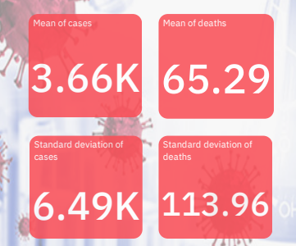

**For Cases:**

* The mean number of daily cases is relatively low, averaging around 3,660 cases. This suggests that the typical daily case count is not exceptionally high.
* The high standard deviation of approximately 6,490 indicates significant variability in daily case counts. Some days may have substantially more cases than the mean, while others may have fewer, suggesting inconsistent infection rates.
* The data exhibits fluctuations in daily case counts, reflecting periods of both increased and decreased infections during the analysed timeframe.

**For Deaths:**

* In contrast to cases, the mean daily death count is considerably higher, at an average of 65.29 deaths. This indicates a more severe impact in terms of fatalities.
* The standard deviation for deaths, standing at approximately 113.96, is notably high. This underscores substantial variability in daily death counts, with some days experiencing significantly more deaths than the mean, while others have fewer deaths.
* The high standard deviation for deaths suggests that the mortality rate fluctuates considerably, emphasizing the unpredictability and volatility of the virus's impact on different days within the specified period.

1. PROVIDING THE OVERVIEW OF CASES AND DEATHS

TOTAL CASES

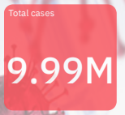

INSIGHTS

* The insight from the dataset reveals that during the months of **March, April, and May, 2021**, the cumulative number of COVID-19 cases in the dataset reached approximately **9.99 million.**
* This indicates a substantial level of infections within this three-month period, underlining the significant impact of the virus using the **summary visual**.

TOTAL DEATHS

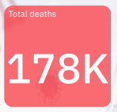

INSIGHTS

* The dataset indicates that during the combined months of **March, April, and May, 2021,** there were a total of **178,000** reported COVID-19 cases.
* This data suggests a notable level of infections within this three-month period using the **summary visual**.

1. WHICH COUNTRY HAS THE HIGHEST NUMBER OF CASES

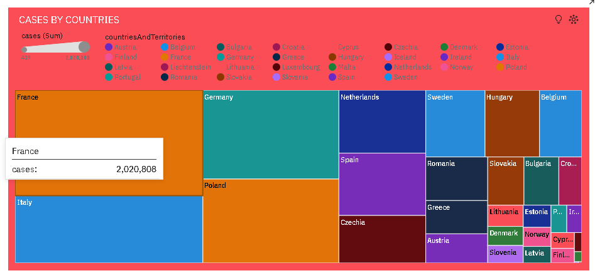

INSIGHTS

* Cases ranges from 437 in Liechtenstein, to over 2.0 million in France.
* From 2021-03-29 to 2021-03-30, France's cases increased by 937%.
* Overall sum of cases is nearly 10.0 million.
* It is projected that by 2021-06-19, France will exceed Germany in cases by over 14 thousand.

1. WHICH COUNTRY HAS THE HIGHEST NUMBER OF CASES.

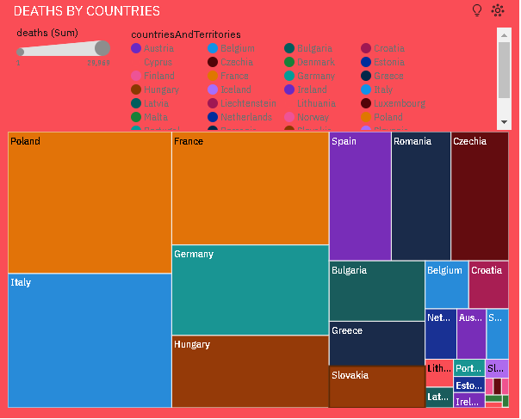

INSIGTHS

* Deaths is unusually high in Poland, Italy and France.
* Across all values, the sum of deaths is over 178 thousand.
* Deaths ranges from 1 in Iceland to almost 30 thousand in Poland.

1. TOP 5 COUNTRIES WITH HIGHEST NUMBER OF COVID 19 CASES

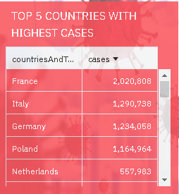

INSIGHTS

* France (2,020,808 cases): France has faced a substantial number of COVID-19 cases, reflecting the challenges in containing the virus. This high case count underscores the need for ongoing public health measures and vaccination campaigns to mitigate the spread.
* Italy (1,290,738 cases): Italy, one of the early epicenters of the pandemic, continues to grapple with a significant number of cases. It highlights the importance of sustained vigilance and healthcare preparedness.
* Germany (1,234,758 cases): Germany, known for its robust healthcare system, still faces a considerable case load. The data emphasizes the persistence of COVID-19 and the need for adaptive strategies.
* Poland (1,164,964 cases): Poland's notable case count suggests ongoing challenges in controlling the virus. This underscores the importance of vaccination and adhering to public health guidelines.
* Netherlands (557,983 cases): The Netherlands has experienced a substantial number of COVID-19 cases. This data reflects the global nature of the pandemic and the need for international cooperation in controlling its spread.
* These insights highlight that COVID-19 remains a global challenge, with countries continuing to grapple with significant case numbers. It underscores the importance of vaccination, public health measures, and data-driven decision-making to curb the spread of the virus.

1. TOP 5 COUNTRIES WITH LOWER NUMBER OF COVID 19 CASES.

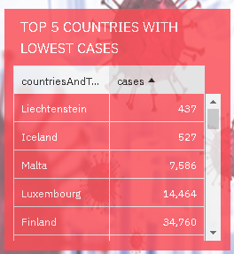

* Liechtenstein (437 cases): Liechtenstein's low case count reflects effective containment measures and a small population. It underscores the advantages of early intervention in limiting virus spread.
* Iceland (527 cases): Iceland's success in maintaining a low case count is attributed to a robust healthcare system and early testing and contact tracing efforts.
* Malta (7,586 cases): Malta has managed to keep its case count comparatively low. Effective public health measures and vaccination campaigns likely play a role in this achievement.
* Luxembourg (14,464 cases): Luxembourg's case count, while higher than the previous countries, is still relatively low. Stringent measures and a responsive healthcare system may contribute to this outcome.
* Finland (34,760 cases): Finland has maintained a modest case count compared to larger European countries. The data suggests a combination of strict public health measures and a health-conscious population.
* These insights highlight the effectiveness of timely public health measures, testing, contact tracing, and vaccination strategies in managing and limiting COVID-19 cases in these countries.

1. TOP 5 COUNTRIES WITH HIGHEST NUMBER OF DEATHS.

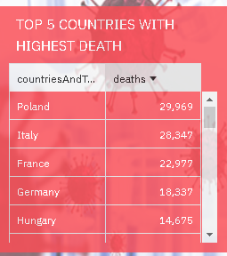

INSIGHTS

* Poland (29,969 deaths): Poland has experienced a significant number of COVID-19 fatalities, highlighting the importance of continued efforts to manage the pandemic effectively.
* Italy (28,347 deaths): Italy, which faced a severe outbreak early in the pandemic, continues to grapple with a substantial death toll, emphasizing the need for ongoing vigilance.
* France (22,977 deaths): France has also faced a considerable number of COVID-19 fatalities, underscoring the importance of healthcare preparedness and public health measures.
* Germany (18,337 deaths): Germany, known for its robust healthcare system, has experienced a notable number of deaths, indicating the global challenges in managing the virus.
* Hungary (14,675 deaths): Hungary's death count, while lower than the previously mentioned countries, is still significant. It highlights the need for vaccination campaigns and adherence to public health guidelines.
* These insights illustrate the impact of the COVID-19 pandemic on these European countries and emphasize the importance of ongoing measures to reduce mortality and prevent further infections.

1. TOP 5 COUNTRIES WITH LOWEST NUMBER OF DEATHS.

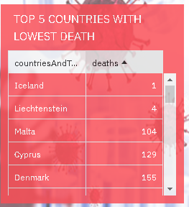

INSIGHTS

* Iceland (1 death): Iceland's exceptionally low death count underscores the effectiveness of its response and healthcare system in minimizing fatalities.
* Liechtenstein (4 deaths): Liechtenstein's minimal number of deaths reflects successful efforts in containment and healthcare management.
* Malta (104 deaths): Malta's relatively low death count suggests effective public health measures and healthcare responses in the face of the pandemic.
* Cyprus (129 deaths): Cyprus has managed to keep its death count relatively low through responsive measures and effective healthcare provision.
* Denmark (155 deaths): Denmark's modest death count, compared to larger European countries, highlights the efficacy of its public health policies and healthcare system.
* These insights illustrate how these countries have been successful in keeping COVID-19 death numbers relatively low, primarily through proactive public health measures and efficient healthcare systems.

1. TOP 5 COUNTRIES WITH HIGHEST NUMBER OF DEATHS.

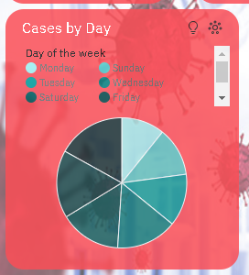

INSIGHTS

* Thursday has the highest total cases on 2021-04-01.
* For cases, the most significant values of Day of the week are Thursday, Friday, Saturday, and Wednesday, whose respective cases values add up to over 6.4 million, or 64.1 % of the total.
* Cases ranges from almost 1.1 million, when Day of the week is Monday, to nearly 1.7 million, when Day of the week is Thursday.

1. TOP 5 COUNTRIES WITH HIGHEST NUMBER OF DEATHS.

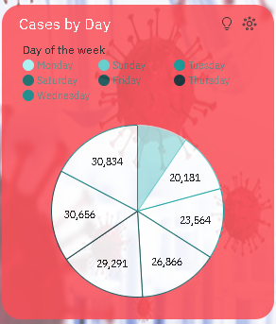

INSIGHTS

* Wednesday has the highest total deaths especially on 2021-04-14.
* Deaths is unusually low when Day of the week is Monday.
* Friday has a deaths of almost 3500 on 2021-04-09.
* Across all day of the weeks, the sum of deaths is over 178 thousand.
* Deaths ranges from nearly 17 thousand, when Day of the week is Monday, to nearly 31 thousand, when Day of the week is Wednesday.
* For deaths, the most significant values of Day of the week are Wednesday, Thursday, Friday, Saturday, and Tuesday, whose respective deaths values add up to over 141 thousand, or 79.2 % of the total.

1. MONTHLY CASES CHART

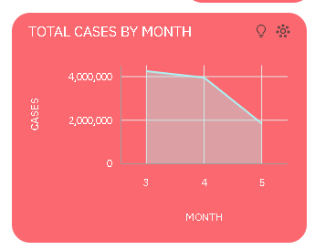

**INSIGHTS**

* Cases is unusually low in the month of May.
* April month has the highest Total deaths but is ranked #2 in Total cases.
* March month has the highest Total cases but is ranked #2 in Total deaths.
* Over all months, the sum of cases is nearly 10.0 million.
* Cases ranges from over 1.8 million, when month is 5, to over 4.2 million, in the month of march.
* For cases, the most significant values of month are march and april, whose respective cases values add up to almost 8.2 million, or 81.7 % of the total.

1. MONTHLY DEATHS CHART

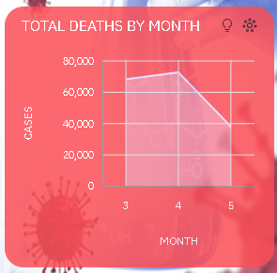

**INSIGHTS**

* Deaths is unusually low when month of May.
* March has the highest Total cases but is ranked #2 in Total deaths.
* April has the highest Total deaths but is ranked #2 in Total cases.
* Across all months, the sum of deaths is over 178 thousand.
* Deaths ranges from nearly 38 thousand, when month is May, to over 72 thousand, when month is April.
* For deaths, the most significant values of month are March and April, whose respective deaths values add up to over 140 thousand, or 78.8 % of the total.

1. MARCH MONTH CASES TRENDS

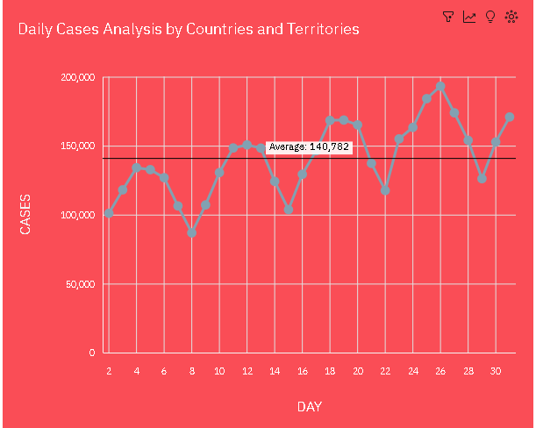

INSIGHTS

* Cases has a strong weekly trend. The largest values typically occur at period 3, whereas the smalest values at period 7.
* Cases has a strong upward trend.
* Based on the current forecasting, cases may reach nearly 171 thousand by day 37.
* Across all days, the sum of cases is over 4.2 million.
* Cases ranges from nearly 87 thousand, when day is 8, to over 193 thousand, when day is 26.
* For cases, the most significant values of day are 26 and 25, whose respective cases values add up to over 377 thousand, or 8.9 % of the total.

1. MARCH MONTH CASES TRENDS

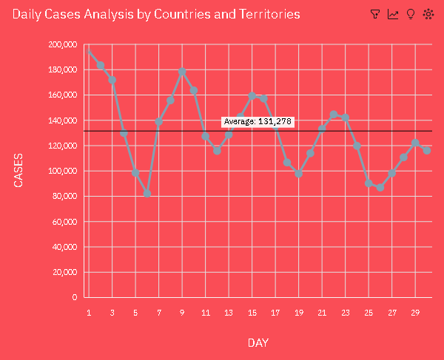

INSIGHTS

* Cases has a moderate weekly trend. The largest values typically occur at period 2, whereas the smallest values at period 5.
* Cases has a moderate downward trend.
* Based on the current forecasting, cases may reach nearly 106 thousand by day 36.
* Across all days, the sum of cases is over 3.9 million.
* Cases ranges from nearly 82 thousand, when day is 6, to over 194 thousand, when day is 1.

1. MAY MONTH CASES TRENDS

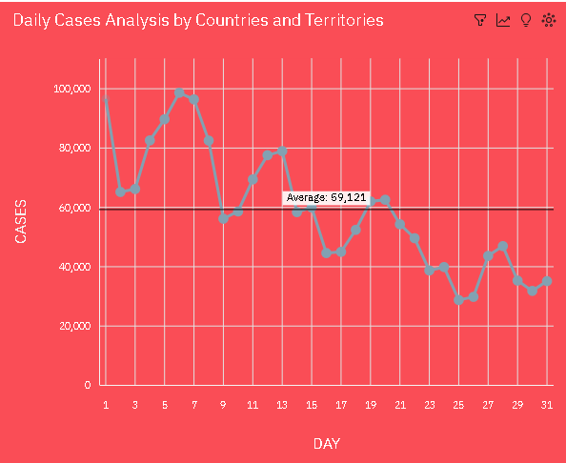

INSIGHTS

* Cases has a strong weekly trend.
* The largest values typically occur at period 6, whereas the smallest values at period 2.
* cases has a strong downward trend.
* Based on the current forecasting, cases may reach almost 30 thousand by day 38.
* Across all days, the sum of cases is over 1.8 million.
* cases ranges from almost 29 thousand, when day is 25, to over 98 thousand, when day is 6.
* For cases, the most significant values of day are 6, 1, 7, and 5, whose respective cases values add up to almost 381 thousand, or 20.8 % of the total.

1. MARCH MONTH DEATHS TRENDS

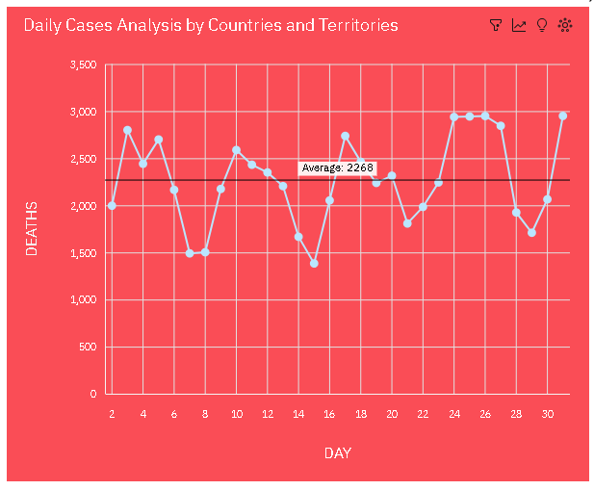

INSIGHTS

* Deaths has a strong weekly trend. The largest values typically occur at period 2, whereas the smallest values at period 7.
* Deaths has a weak upward trend.
* Based on the current forecasting, deaths may reach almost 2500 by day 37.
* Across all days, the sum of deaths is over 68 thousand.
* Deaths ranges from almost 1500, when day is 15, to nearly three thousand, when day is 31.
* For deaths, the most significant values of day are 31, 26, 25, 24, and 27, whose respective deaths values add up to almost fifteen thousand, or 21.5 % of the total.

1. APRIL MONTH DEATHS TRENDS

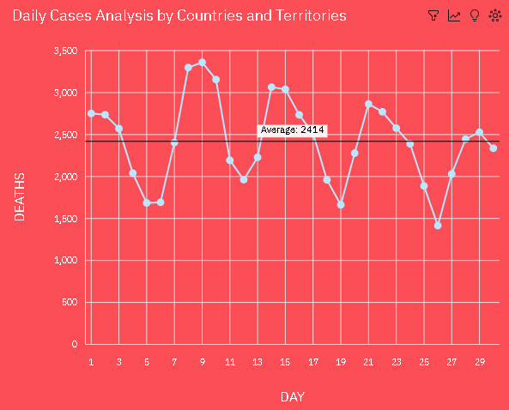

INSIGHTS

* Deaths has a strong weekly trend. The smallest values typically occur at period 5.
* Based on the current forecasting, deaths may reach almost 2500 by day 36.
* Across all days, the sum of deaths is over 72 thousand.
* deaths ranges from almost 1500, when day is 26, to almost 3500, when day is 9.
* For deaths, the most significant values of day are 9 and 8, whose respective deaths values add up to over 6500, or 9.2 % of the total.

1. **MAY MONTH DEATHS TRENDS**

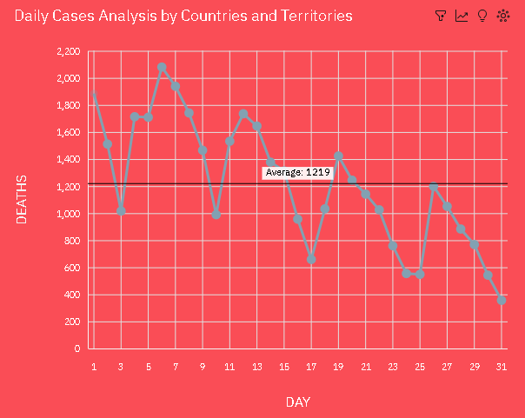

INSIGHTS

* deaths has a strong weekly trend. The largest values typically occur at period 6, whereas the smalest values at period 3.
* deaths has a strong downward trend.
* Based on the current forecasting, deaths may reach -37.83 by day 38.
* Over all days, the sum of deaths is nearly 38 thousand.
* deaths ranges from 356, when day is 31, to over two thousand, when day is 6.

**References:**

1. [**https://www.nature.com/articles/s41581-020-00336-9**](https://www.nature.com/articles/s41581-020-00336-9)
2. [**https://www.sciencedirect.com/science/article/pii/S2210670720308362**](https://www.sciencedirect.com/science/article/pii/S2210670720308362)
3. [**https://www.sciencedirect.com/science/article/pii/S0306261920317906**](https://www.sciencedirect.com/science/article/pii/S0306261920317906)
4. [**https://link.springer.com/article/10.1007/s11125-020-09464-3?error=cookies_not_support**](https://link.springer.com/article/10.1007/s11125-020-09464-3?error=cookies_not_support)

**Conclusion:**

The analysis of COVID-19 cases and deaths data for March, April, and May 2021 highlights the dynamic nature of the pandemic. March and April saw surges in cases and deaths, with clear weekly trends. Countries with effective containment measures and healthcare systems reported lower case and death counts. The data emphasizes the ongoing challenges in managing the virus and the importance of public health measures, vaccination campaigns, and data-driven decision-making. These insights can guide evidence-based responses and preparedness for future waves of the pandemic.